***WORK AT YOUR WILL***

*A*

*Project Report*

*Submitted in partial fulfilment of the*

*Requirements for the award of the Degree of*

**BACHELOR OF ENGINEERING**

IN

**INFORMATION TECHNOLOGY**

By

**M.AMRUTH SAI (1602-19-737-066)**

**K.BHARATH (1602-19-737-069)**

**B.JOSEPH (1602-19-737-074)**

*Under guidance of*

**Mrs.M.SATHYADEVI**

**Assistant Professor**



**Department of Information Technology**

**Vasavi College of Engineering (Autonomous)**

**(Affiliated to Osmania University) Ibrahimbagh,**

**Hyderabad-31 2021-2022 Vasavi College of Engineering (Autonomous)**

**(Affiliated to Osmania University) Ibrahimbagh, Hyderabad-31**

**Department of Information Technology**



**DECLARATION BY THE CANDIDATES**

We, **M.AMRUTH SAI , K.BHARATH, B.JOSEPH** bearing hall ticket numbers, **1602-19-737-066, 1602-19-737-069, 1602-19-737-074** hereby declare that the project report entitled “**WORK AT YOUR WILL**” under the guidance of **Mrs.M.SATHYADEVI**, Professor, Department of Information Technology, Vasavi College of Engineering, Hyderabad, is submitted in partial fulfilment of the requirement of THEME BASED PROJECT of V semester of **Bachelor of Engineering in Information Technology**.

This is a record of bonafide work carried out by us and the results embodied in this project report have not been submitted to any other university or institute for the award of any other degree or diploma.

**M.AMRUTH SAI (1602-19-737-066)**

**K.BHARATH (1602-19-737-069)**

**B.JOSEPH (1602-19-737-074)**

**Vasavi College of Engineering (Autonomous)**

**(Affiliated to Osmania University) Ibrahimbagh, Hyderabad-31**

**Department of Information Technology**



**BONAFIDE CERTIFICATE**

This is to certify that the project entitled "**WORK AT YOUR WILL**” being submitted by **M. AMRUTH SAI, K.BHARATH, B.JOSEPH** bearing **1602-19-737-066, 1602-19-737-069, 1602-19-737-074** in partial fulfilment of the requirements for the completion of MINI PROJECT of Bachelor of Engineering in Information Technology is a record of bonafide work carried out by them under my guidance.

**Mrs.M.SathyaDevi Dr. K. Ram Mohan Rao**

**Assistant Professor HOD, IT**

**Internal Guide**

**ACKNOWLEDGEMENT**

The satisfaction that accompanies that the successful completion of the project would not have been possible without the kind support and help of many individuals. We would like to extend my sincere thanks to all of them. We would like to take the opportunity to express our humble gratitude to Mrs.M.**SATHYADEVI** (Assistant Professor) under whom we executed this project. We would also use this opportunity to thank our Head Of Department Dr. K.Ram Mohan Rao. We would also like to thank all faculty members and staff of the Department of Information Technology for their generous help in various ways for the completion of this project.

Finally, we would like to express our heartfelt thanks to our senior **SRIRANGAM.YUKTH (1602-18-737-060)**. We are grateful to his guidance, and constructive suggestions that helped us in the preparation of this project. His constant guidance and willingness to share his vast knowledge made us understand this project and its manifestations in great depths and helped us to complete the assigned tasks.

**ABSTRACT**

Our **Work At Your** **Will** application is a one-stop solution for all the recruitment needs aims at creating a system which allows a user to finish their work in a easy way and acts as a perfect job search portal for all the skill-full workers who are driven and best at providing their services considering user’s comfort as their priority. Our application creates a collaborative environment for job seekers where all they must do is simply post their information regarding their respective job expertise on our application and the user can get to choose a cook, driver, accountant, hairdresser, sales executive, tailor, photographer etc. depending upon their needs from the available options and hire them temporarily.

**INDEX**

## Contents

**CHAPTER 1**

1. Introduction -------------------------------------------------------------- 8
   1. Motivation
   2. Problem Statement
   3. Project Objectives

**CHAPTER 2** ----------------------------------------------------------------- 9

1. Technical Literature

**CHAPTER 3** ------------------------------------------------------------------ 9

1. Existing Method/System

3.1 Drawbacks

**CHAPTER 4** --------------------------------------------------------------------10

System Requirements and Specifications

* + 1. Software Specifications
    2. Functional Requirements
    3. Non-Functional Requirements
  1. Architecture

**CHAPTER 5** -------------------------------------------------------------------**13**

* 1. Design
     1. UML diagrams / UX diagrams
  2. Database schema

**CHAPTER** 6 ------------------------------------------------------------------**17**

* 1. Implementation and Testing
     1. Screenshots and Test cases

<Important code snippets may be included>

* 1. Results

**CHAPTER 7** ----------------------------------------------------------------- **23**

* 1. Conclusion
  2. Future Scope

**CHAPTER 8** ----------------------------------------------------------------- **24**

References

# CHAPTER 1

# Introduction

### 1.1 Motivation

Many people can’t go outside to complete their work. The user can book the services from our android application. So, our Android application will help them to get proper affordable and reliable services for their need**.**

**1.2 Problem Statement**

We live in a world where time is of prime importance. So often we end up putting our important needs and wants on hold because we can’t find enough time from our busy schedules or find the right person to help us do that. As is the case with all the big problems, this one too has a simple and elegant solution that **Work At Your Will** has successfully captured and implemented.

It is basically an online directory of service providers who can be booked as per your convenience for over 60 hiring services across 5 major categories – Home, Health, Events, Lessons, and other personal services.

**1.3 Project Objectives**

WORK AT YOUR WILL” is a Android-based application where people who want to hire workers for their household works like Electricals, Carpentry can find a worker for the need. Here, the user want to hire can book worker services with the workers at their own time by signing up to WORK AT YOUR WILL using their email id/mobile no.

In return the worker will verify their service requests and approves for services. Then the user needs to complete the payment and can get the service. WORK AT YOUR WILL provides affordable and reliable services for their need

# CHAPTER 2

### 2.1 Technical Literature

We have used xml for user interface. We have used java language for backend , firestore database.

**CHAPTER 3**

**EXISTING SYSTEM**

All the applications systems from the past are limited and are simplest an application which is for hiring the workers and complete their job. The main motto our application is to complete the job with more efficiently use of money.

The existing applications can’t cope up with the bargaining system .which helps the user complete their work more efficiently.

### 3.1 DRAWBACKS

* New users might not be able to know in depth about the application.
* Since there is no physically verification of the site documents so that the users can have complete trust.
* As of now the application cannot work in iOS.

**CHAPTER 4**

**Proposed System**

* 1. **System Requirements and Specifications**
     1. Software Specifications

FLUTTER/ANDROID, XML (FRONT END)

JAVA, FIRESTORE(BACK END)

* + 1. **Functional Requirements**

With the Android application, the users will be able to search the workers according to their preferences. The results will be based on their criteria.

If a user is searching for the worker on what criteria included in the search a list of services will be displayed. Each worker will have the detailed information. The user will also be provided with the location. The location will be redirected to google maps.

Any kind of modifications in the Android app are done only by the admin and some modification permissions are also given to the workers restricted only for his/her property

#### User Characteristics

1. **User:**

* Users have to register into the Android Application and login if account already exists and have to sign up if they are new user.
* The User will choose from the list of available service providers and requests for a service.
* The workers will verify the pending requests and confirms the services slot.
* The User then needs to finish the payment and join the service.

1. **Administrator:**

* Admin is responsible for maintaining and updating android application.
* Admin has access to database.

1. **Worker :**

* The workers have to login to the Android Application.
* The workers will verify the details of the services they provide.
* Add the verified services into the Fire store by which it will get available on the Android Application.
* Has access to Fire store and makes necessary modifications as requested by the user
  + 1. **Non-Functional Requirements**
* **Registration Module:** This module will help the user to register to the Android Application.
* **Login Module:** The users can login to the Android Application once they have successfully registered.
* **Service Module:** The service details like service type, area, price ,location and photos are shown.
* **Search Module:** The specifications applied while searching a services by the tenant will be applied and respective results are shown in a list.

# Architecture

**USER ARCHITECTURE AND WORKER ARCHITECTURE**

1. **User Android**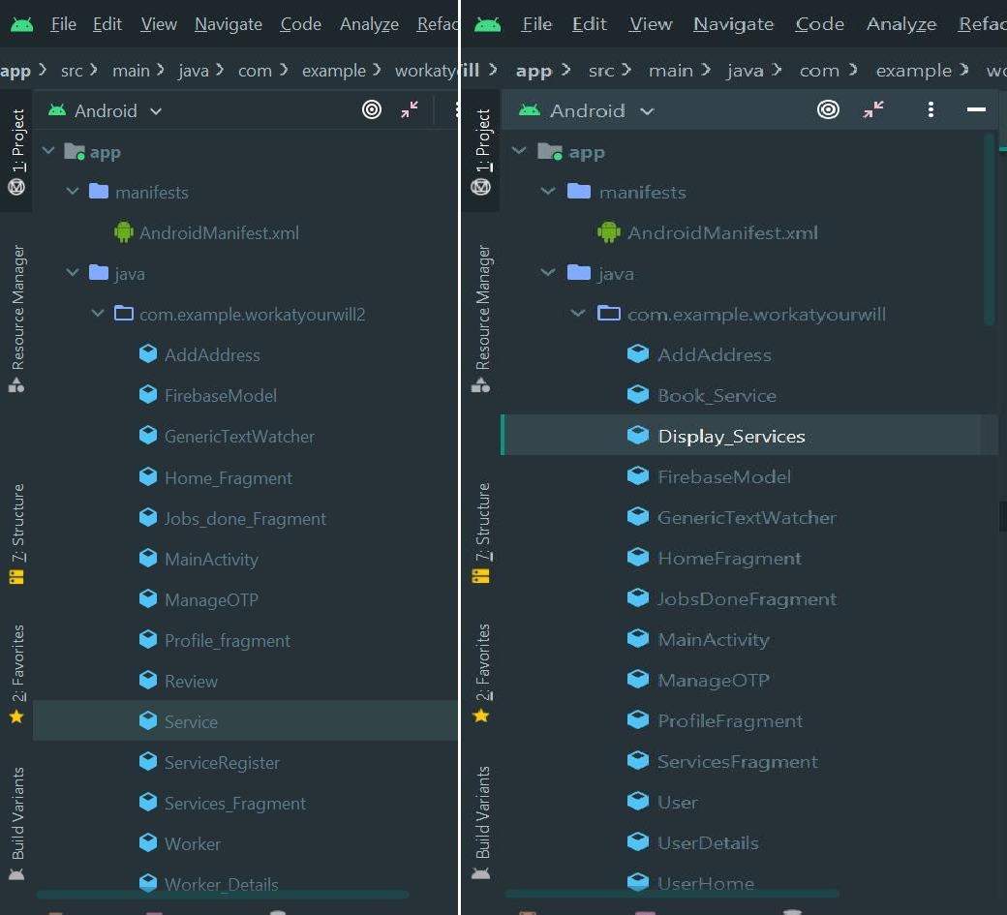

2.Worker Android

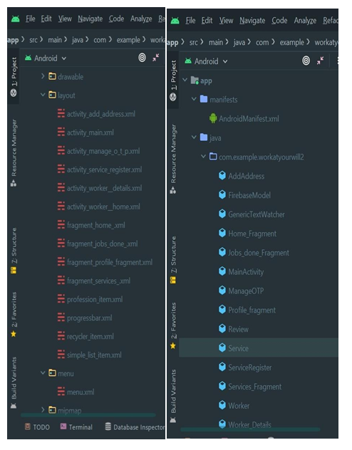

**CHAPTER 5**

* 1. Design

5.1.1 UML diagrams / UX diagrams

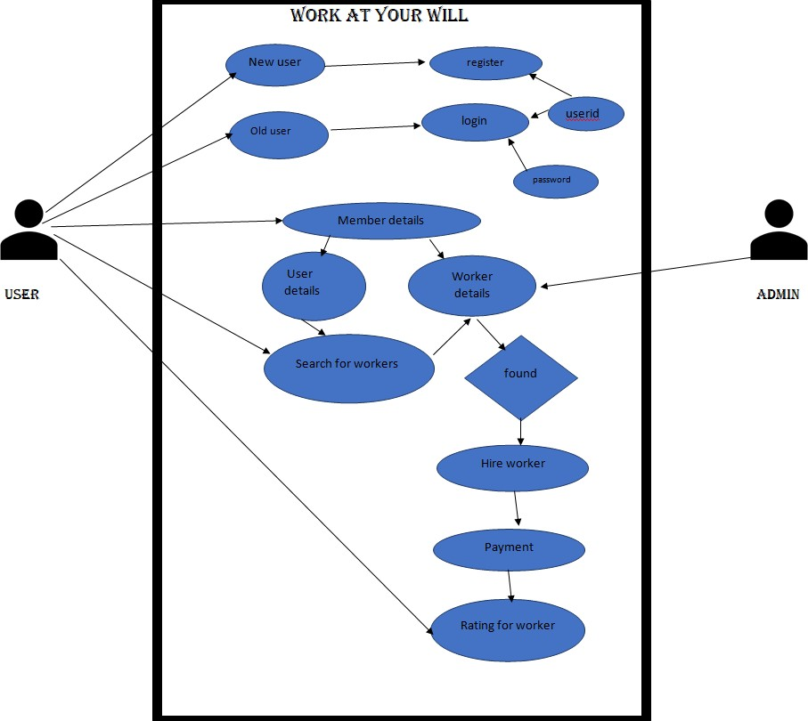

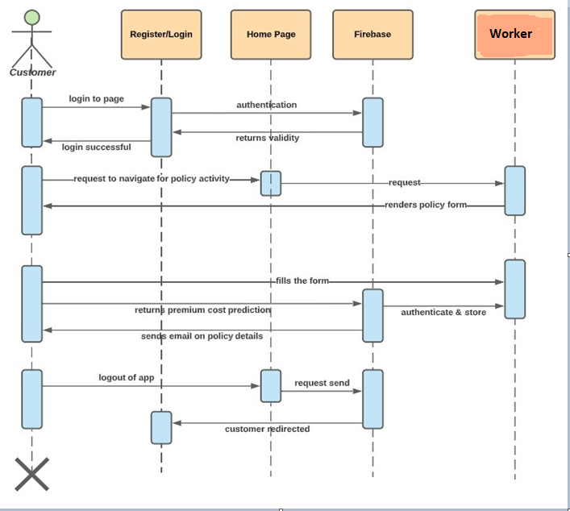

* 1. **Database schema**

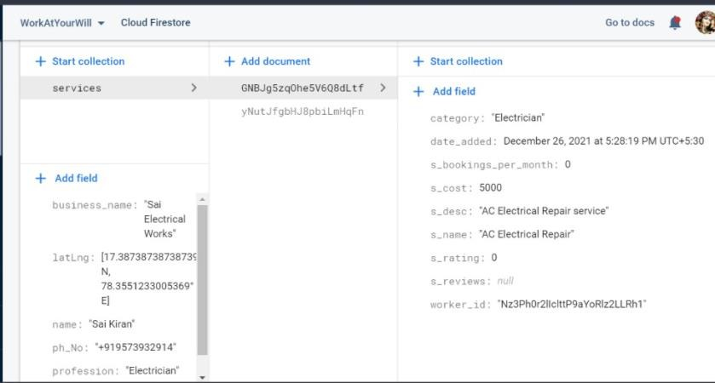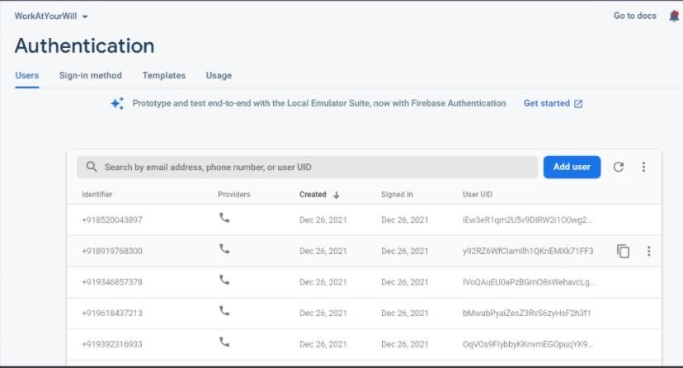

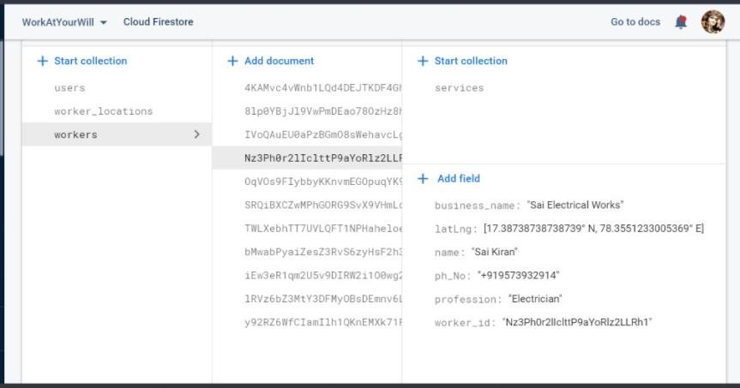

**CHAPTER 6**

**6.1 Implementation and Testing**

**(USER APP -WORK AT YOUR WILL)**

**Home Page:**

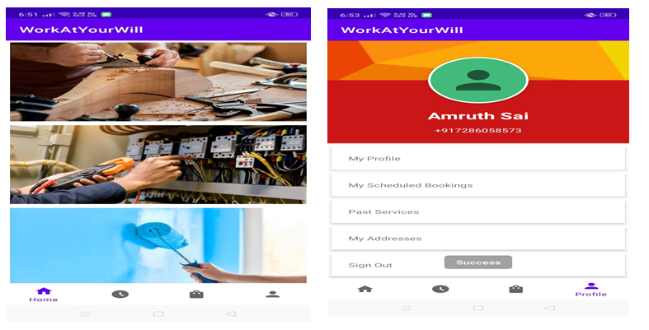

**Login Page**

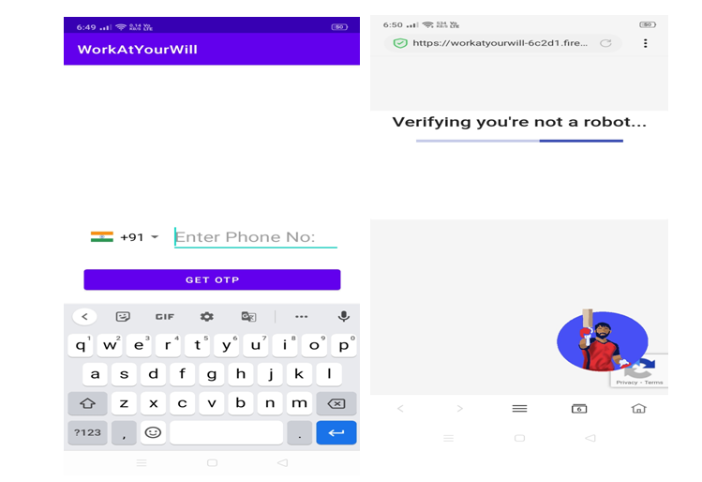

**BOOKING PAGE**

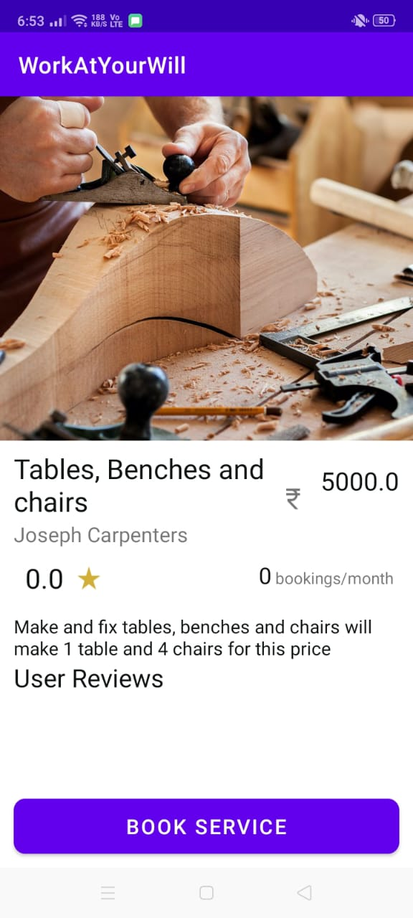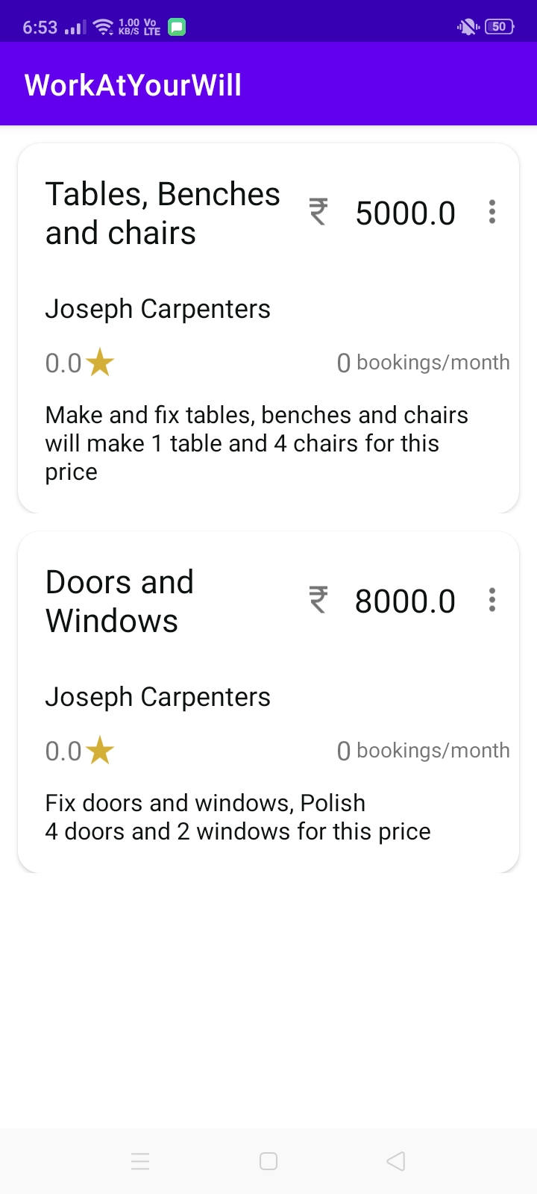

**WORKER APP (WORK AT YOUR WILL-II)**

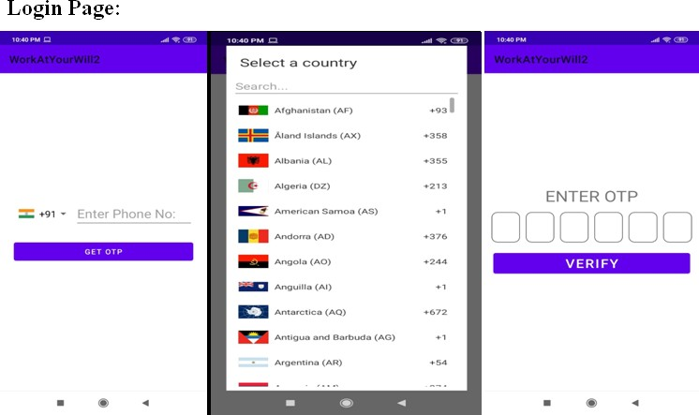

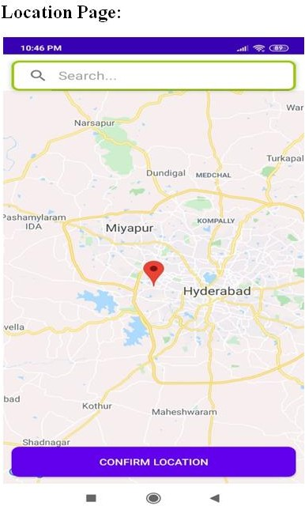

**HOME PAGE:**

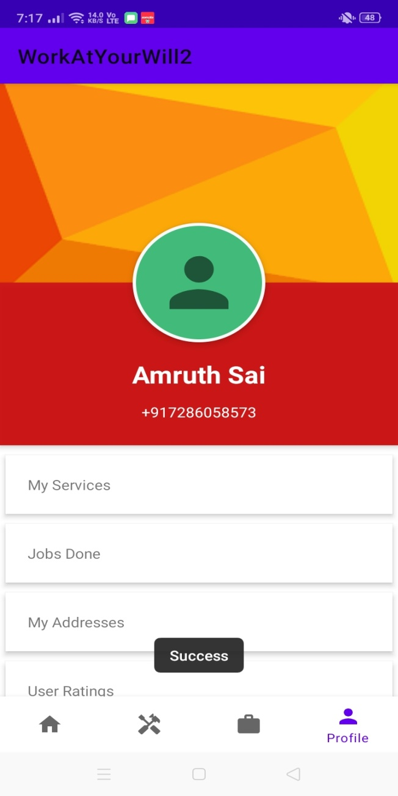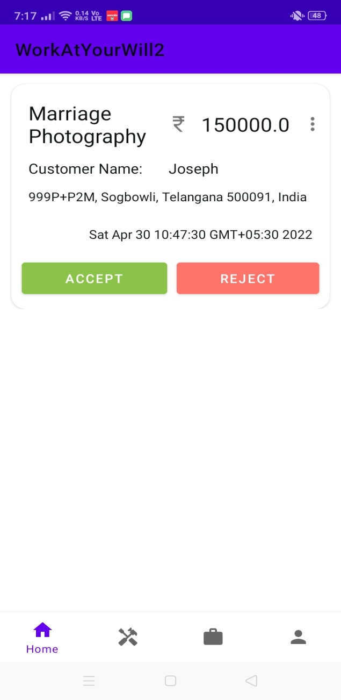

**SERVICE PROVIDED BY WORKER:**

**6.2 RESULTS**

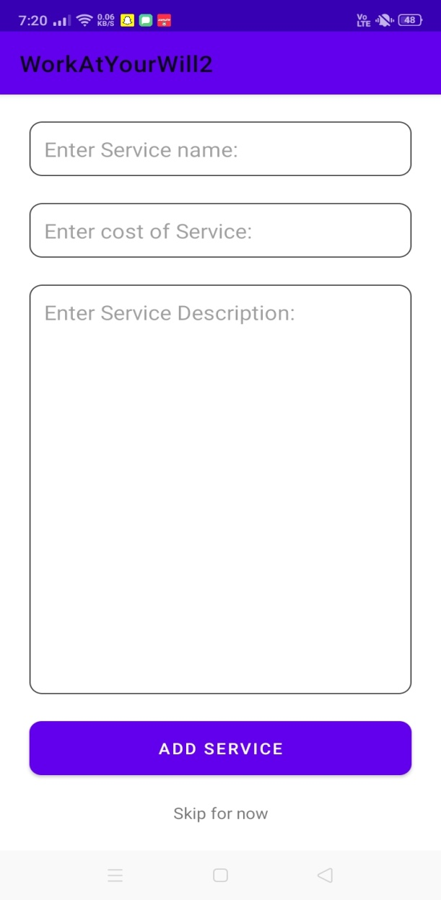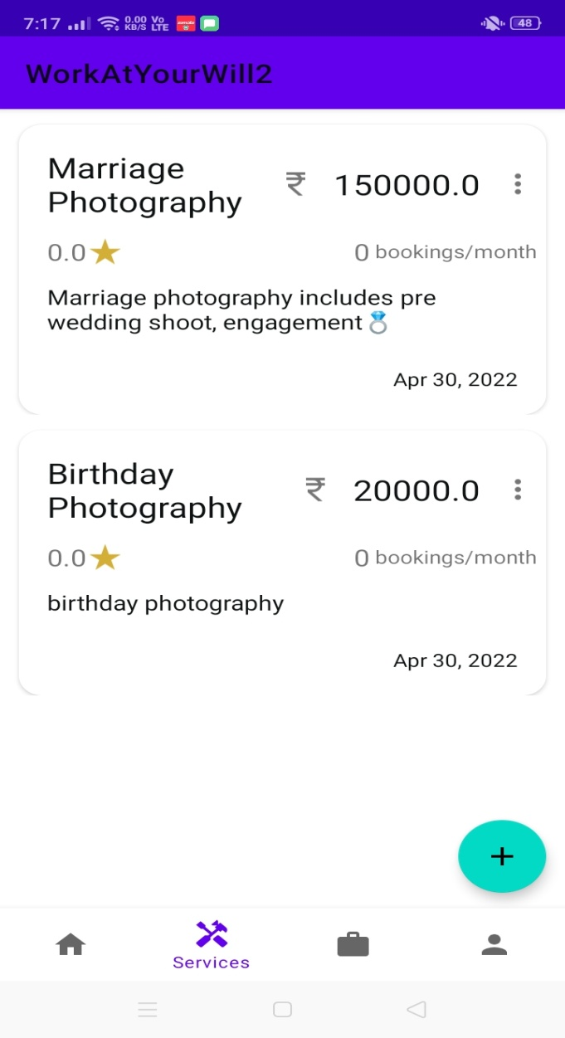

**SCHEDLING JOB PAGE**

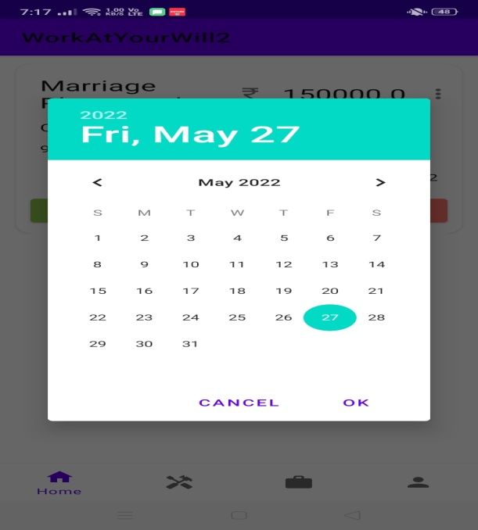

**BARGINING PAGE**

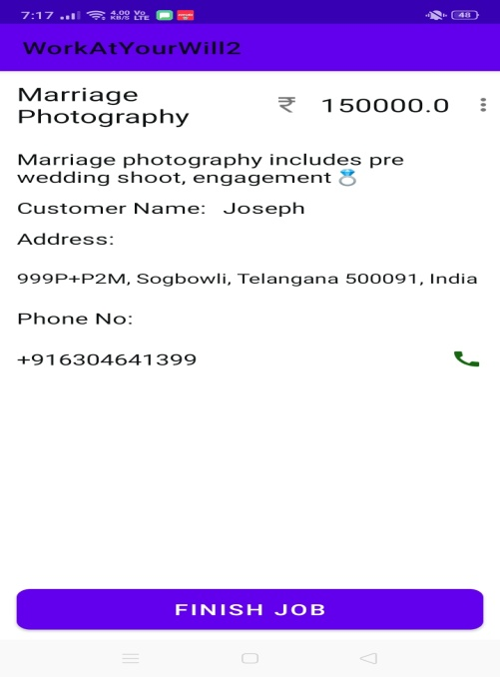

**CHAPTER 7**

**CONCLUSION AND FUTURE SCOPE**

**Conclusion:**

We have successfully developed a secure, user-friendly Android application. This system is capable of searching service providers.

It is developed in Android Studio. The user performs a search for the service providers listings by putting either City/State in the search textbox. The business logic tier communicates with the Fire store tier requesting the results of the query sent by it. The results obtained by the Fire store are displayed on the data grid, by refreshing the grid rather than refreshing the entire Android page.

This system will definitely reduce the time to search for a workers to have it for by having all the service providers online.

**Future scope:**

For the further development of the system an mobile application for Android or iOS can be developed which can make use of the GPS built into the mobile devices to enable service providers to navigate to the location of the user more easily, and will include physical confirmation of the property by our employee and detailed verification of the site documents so that the users will have complete trust.

The future verification process

As of now this project is using the google maps to locate the property, but in future we are planning to have a separate interface in which the location is also navigated in our Android Application itself

**CHAPTER 8**

**REFERENCES**

## REFERENCES

* <https://www.javatpoint.com/dbms-tutorial>
* <https://docs.oracle.com/javase/8/docs/api/>
* [**https://developer.android.com/guide/topics/resources/runtime**](https://developer.android.com/guide/topics/resources/runtime)